**MOBILE COMPUTING WORK**

**LECTURE N0:02**

First we create repository in github named Mobile_Computing_Progress.

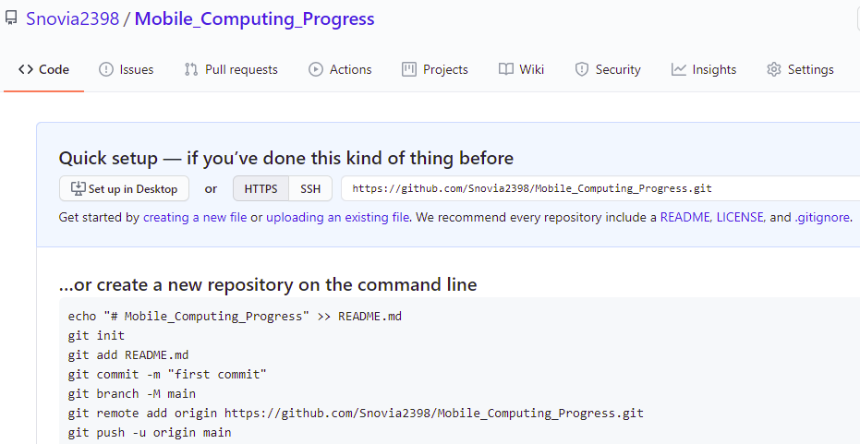

Make folder in your PC named git.

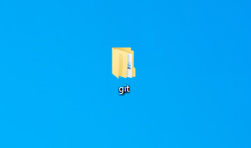

Then using command prompt go to ‘git’ folder using command cd ‘path of that folder’. Run command git clone ‘repository url’.

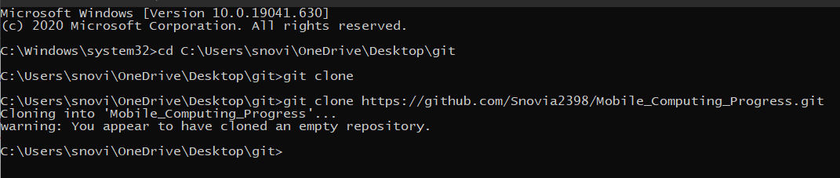

A folder/clone with same name as that of repository is created in folder ‘git’:

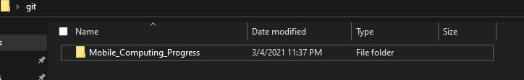

Create a file in this clone/folder and save the file. 1 on the share/Bluetooth video sign shows that same change will have to show in repository.

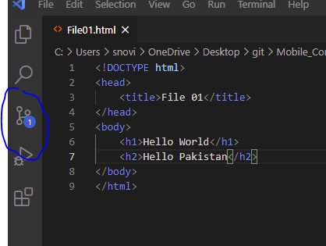

Now add this file to repository using following commands in command prompt.

git add File01.html

git commit -m “First commit ”

git push

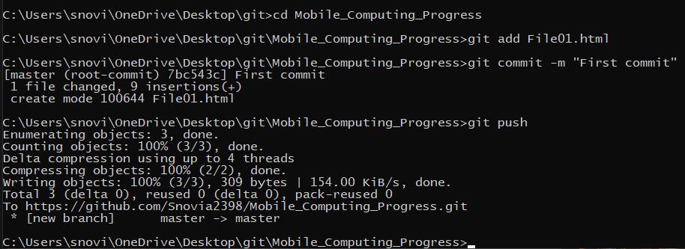

File is added on github

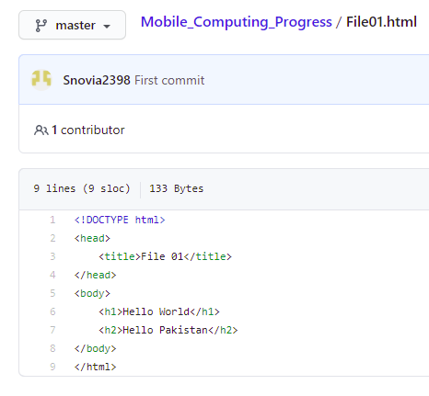

and that sign disappear

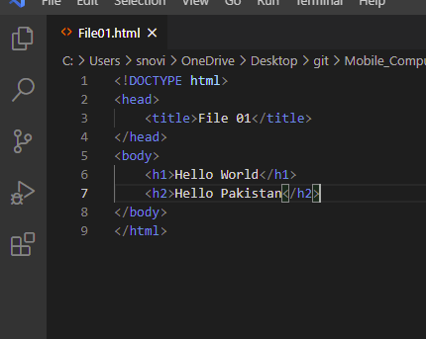

Now make any change in this file in local repository and you see again that sign appear when you save the file because that change is only in local repository but not in online repository.

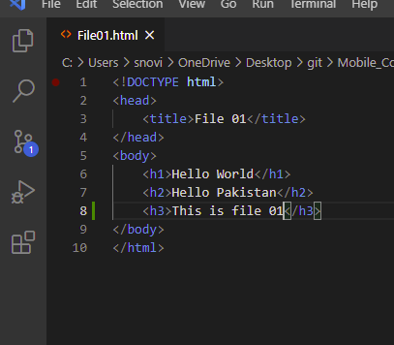

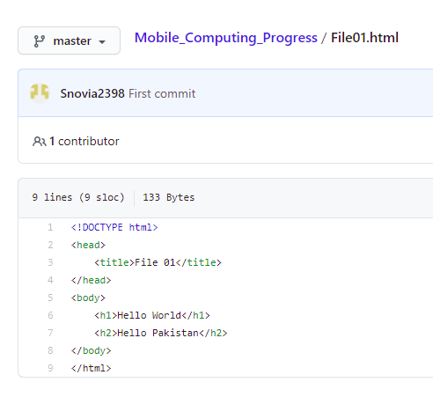

To make changes in online repository also and to remove that sign again run those three commands.

git add File01.html

git commit -m “First commit ”

git push

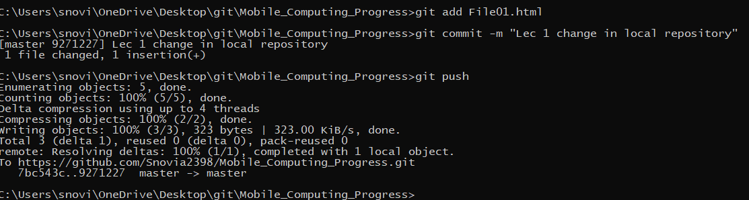

Result is:

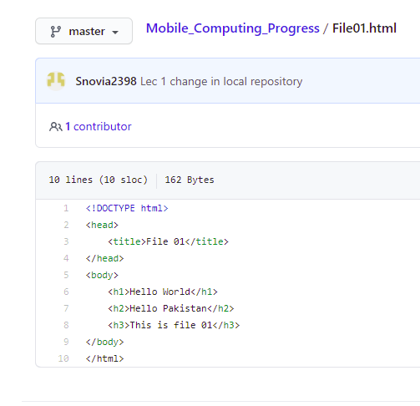

**LECTURE N0:03**

Make any change in file in the git hub online repository not in local repository and you see changes not occur in local repository.

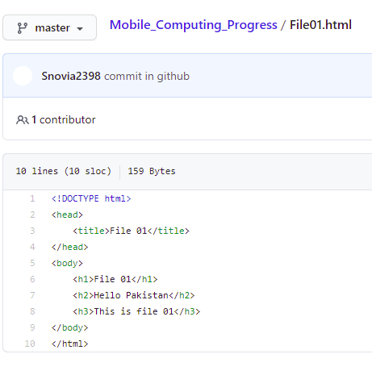

Heading 1 change but that is not changed in local repository.

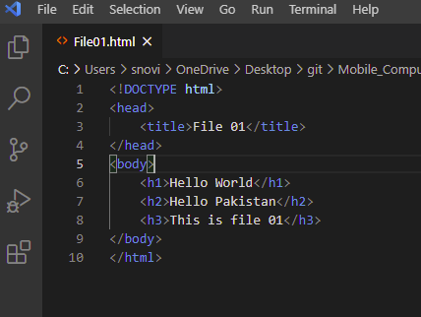

To make change in this file also use command:

git pull

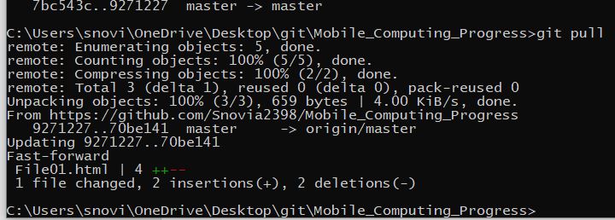

And you see change also occur in local repository.

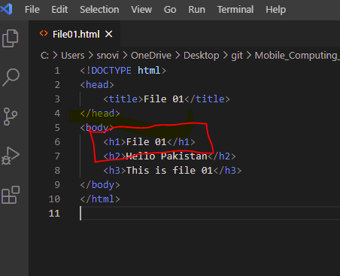

Now see the merge conflict:

When you make changes in both local and online repository conflict occur for example make change in file 1 in online repository

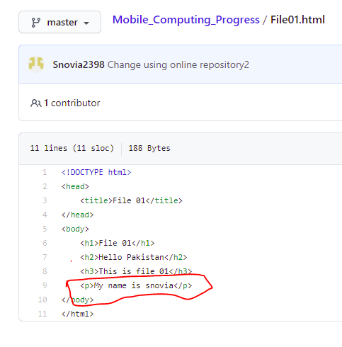

Also change the file in local repository:

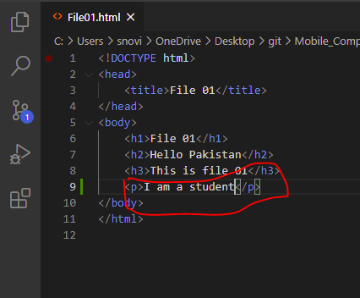

When you commit and push this change to github using command prompt it give error:

git add File01.html

git commit -m “change in local repository2 ”

git push

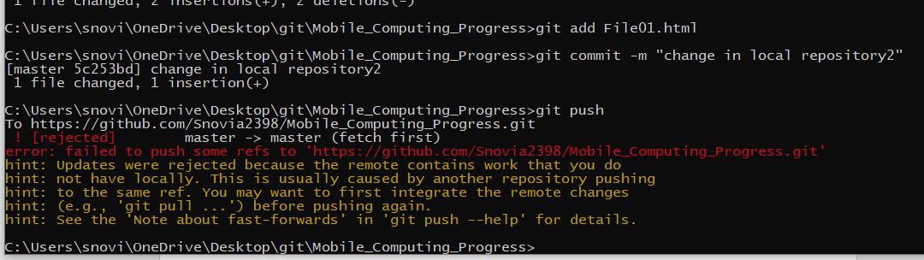

To resolve this issue first run the following command on command prompt

git pull

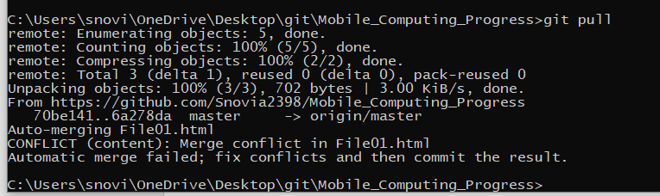

Now in local repository you see file like this:

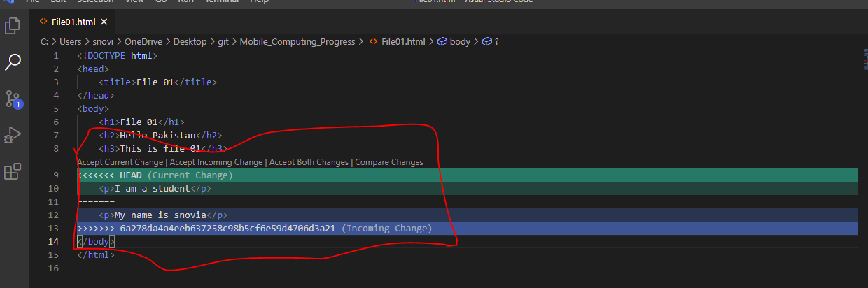

Choose any one option and then push this file to git hub and merge conflict is resolved.

git add File01.html

git commit -m “merge conflict resolved ”

git push

I choose github change by clicking incoming change.

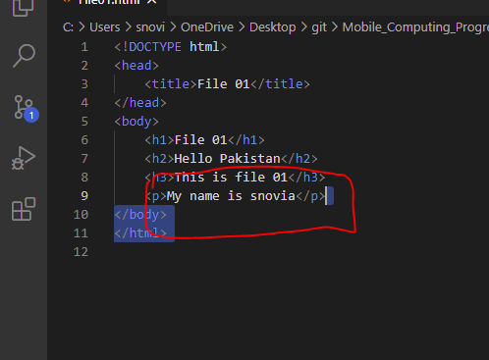

Now run above commands:

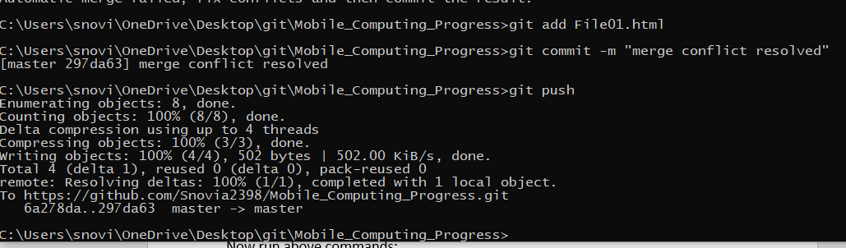

And you see commit change and file in github is present with same change as in local repository.

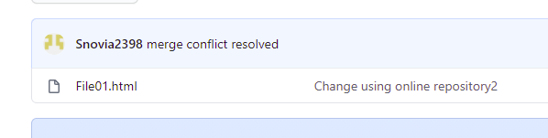

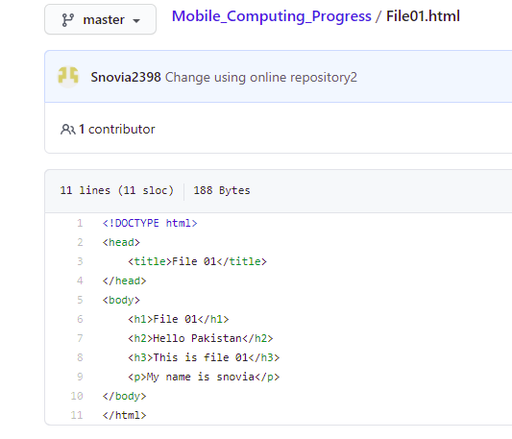

Now make two more files in repository clone

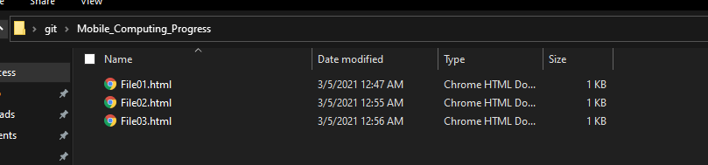

You see two more files are now present in clone folder and now ‘2’ appear because change occur in two files.

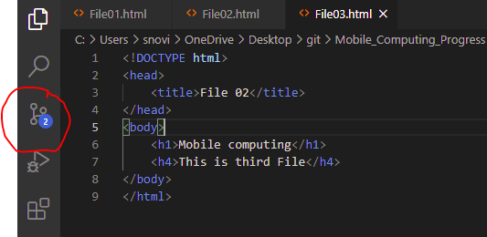

Now push these files to github by using those three commands:

git add File02.html File03.html

git commit -m “Files two and three are added”

git push

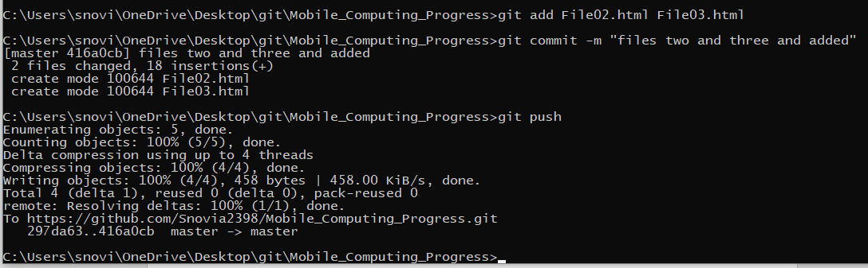

And you see these are present in github

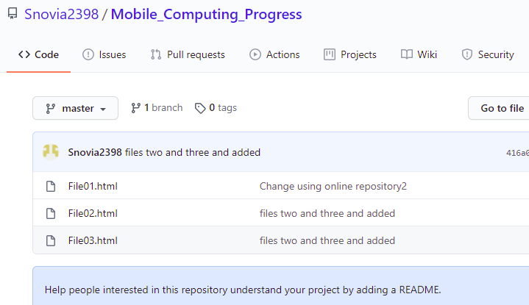

Now delete file 3 by using following command:

git rm File03.html

git add .

git commit -m “”file 3 deleted”

git push

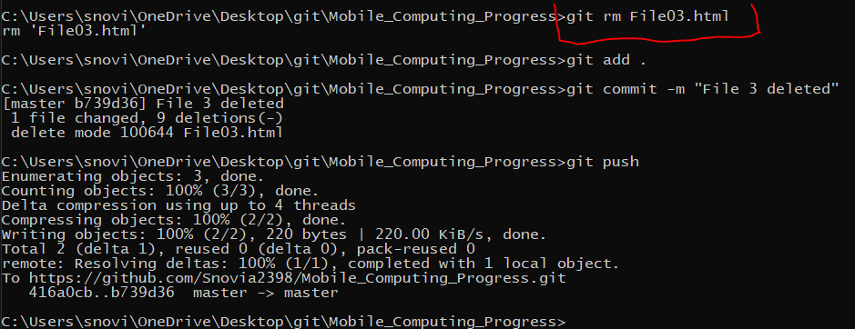

And you see file is deleted

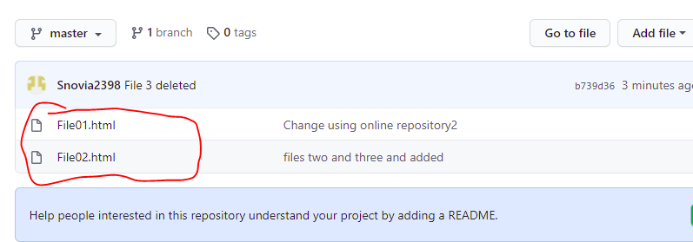

And

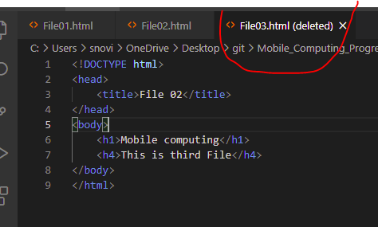

To see the details of commits we use the following command:

git log

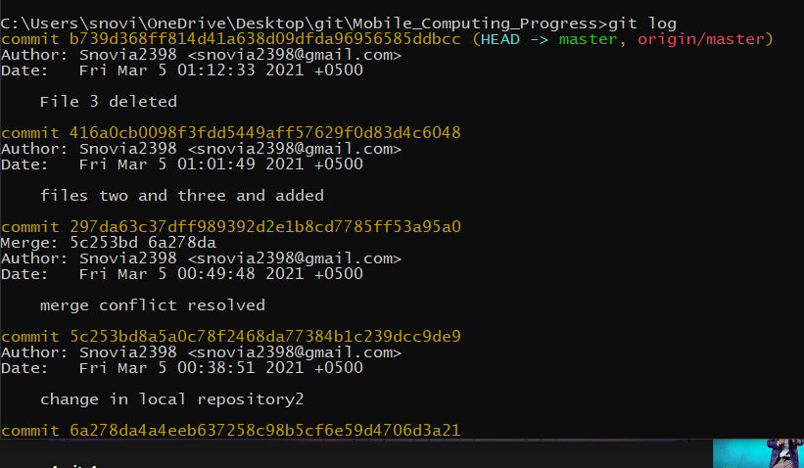

To check the branches we use command:

git branch

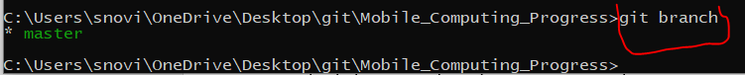

To create new branch we use command:

git checkout -b newBranch



Now your branch is ‘newBranch’

In file02 make changes because you are in newBranch

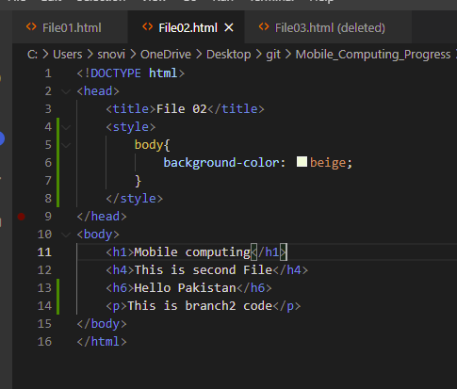

Add this and push this to github:

git commit -am “newBranch changes” (am is use to add and commit both)

git push

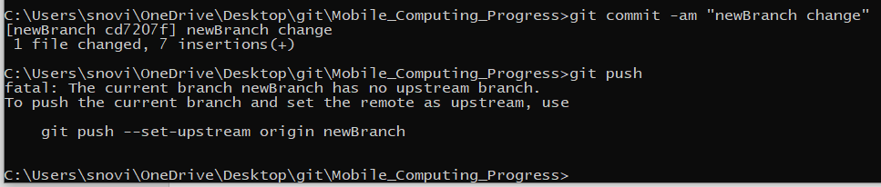

Now you will see when you are in branch ‘master’ code of that branch appear



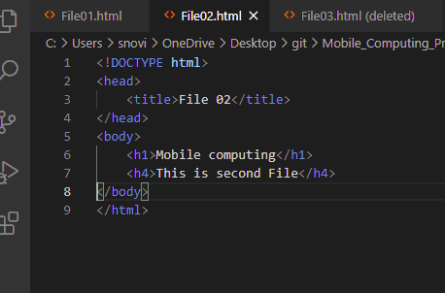

And when you are in ‘newBranch’ code of that appear:

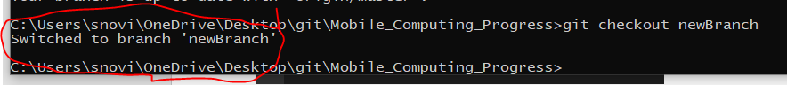

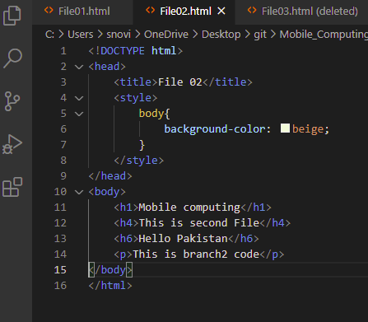

Now merge these two branches code:

First go to ‘master’ branch then following command is used for merging:

git checkout master

git merge newBranch

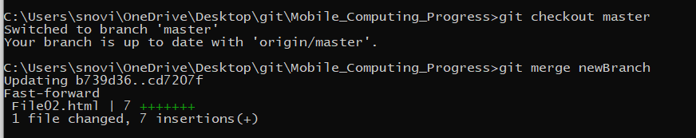

And you see the merging in file

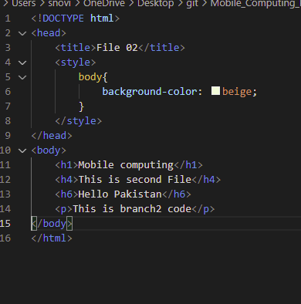

Now delete the ‘newBranch’ by using command:

git branch -D newBranch

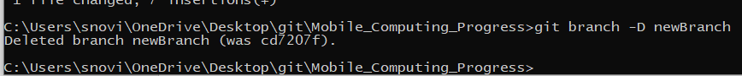

Check the branches:

git branch

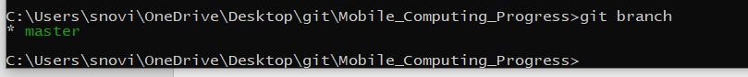

Now add and push the files to github using three commands:

git add .

git commit -a “Testing successful”

git push

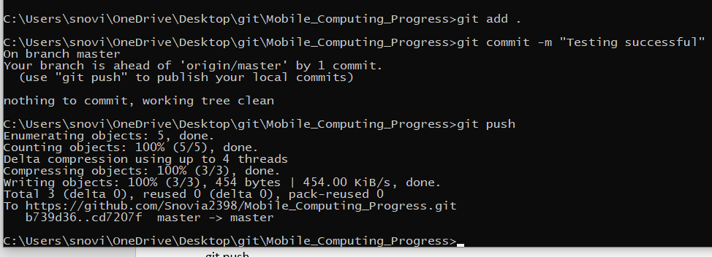

**LECTURE N0:04**

**Class Work:**

Create new repository in git hub as:

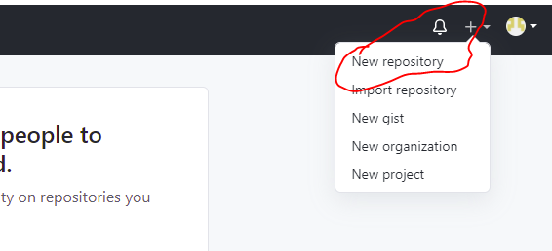

Name this repository ‘Lecture04_Android’ as:

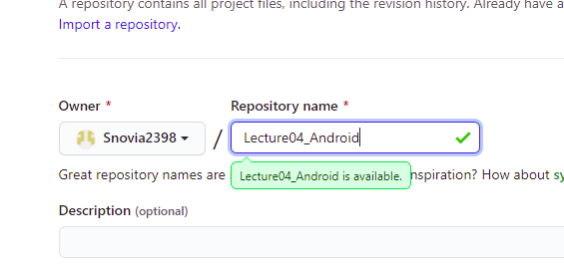

Keep it public and click on create repository as:

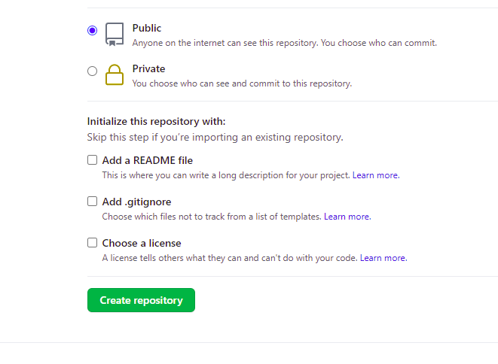

Go to git folder as:

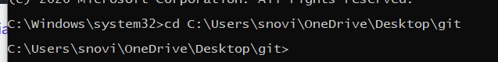

Create clone of repository by giving the url of repository as:

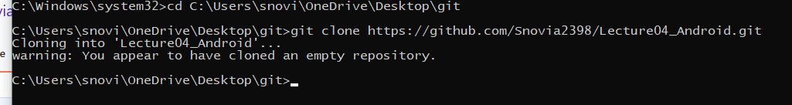

Now go to that clone in git folder:

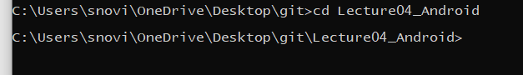

Now create android studio project file in this folder by clicking new project in new in file option:

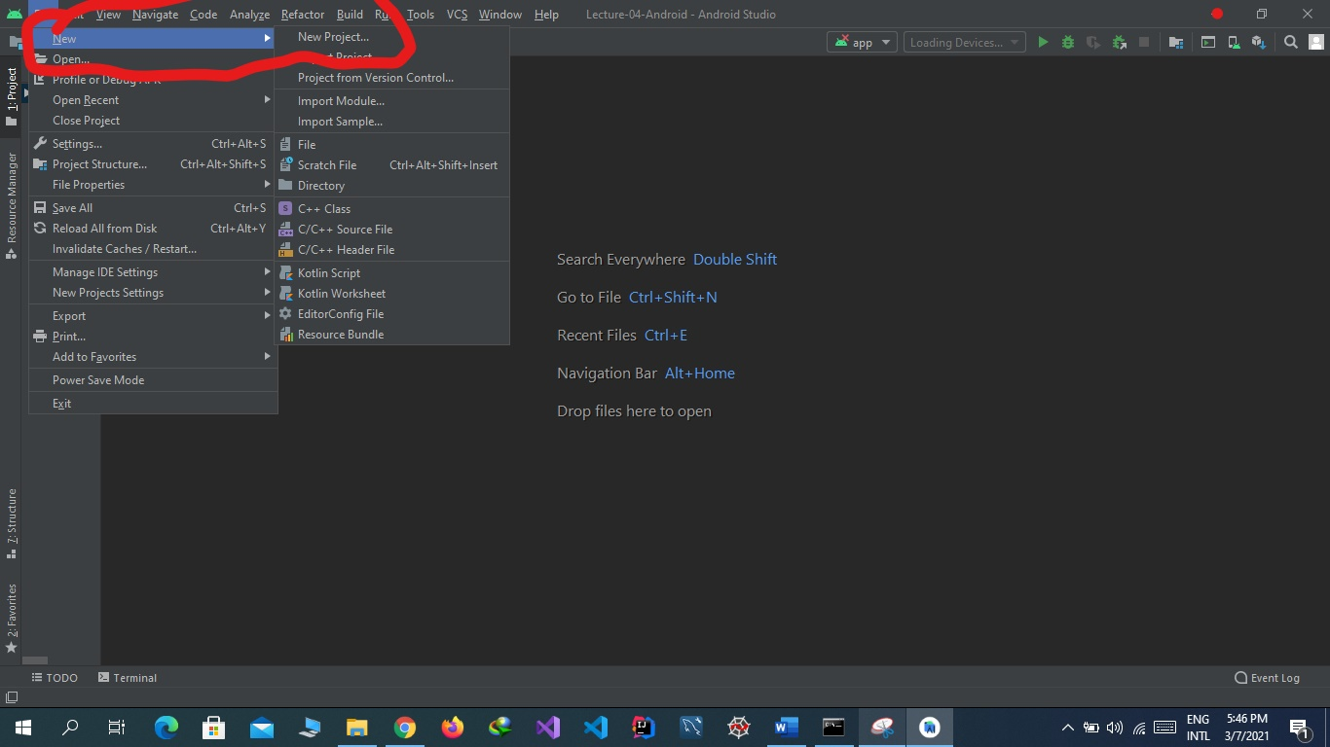

Now select empty project:

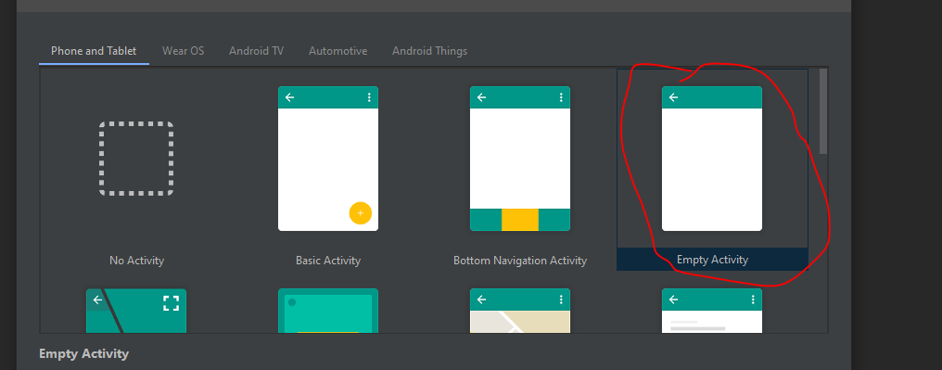

Select name of project, package name that is unique, give location of git hub folder in which clone is present that is location. Select language java and minimum sdk lollipop .

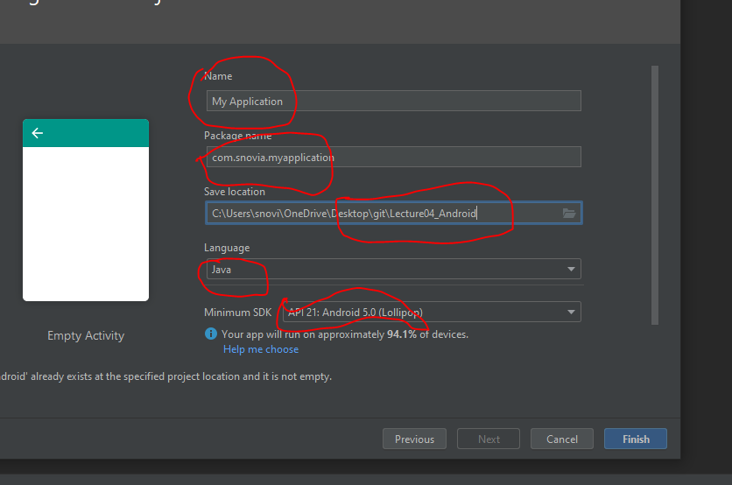

Now go to res option and then layout option and open file activity_main.xml and start work here:

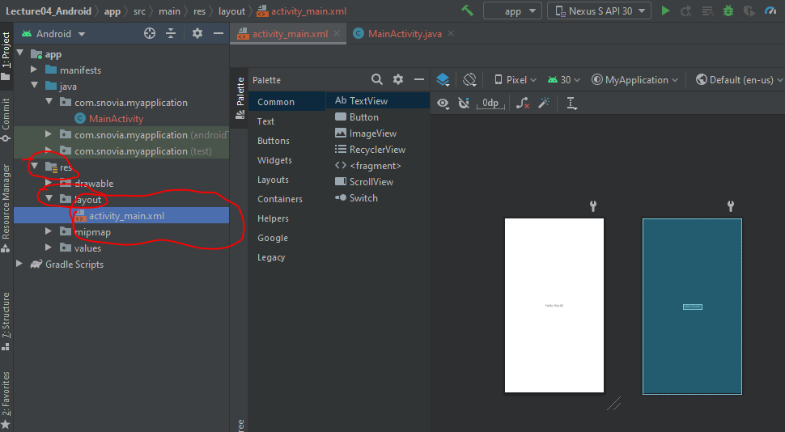

You can choose any design in I choose both:

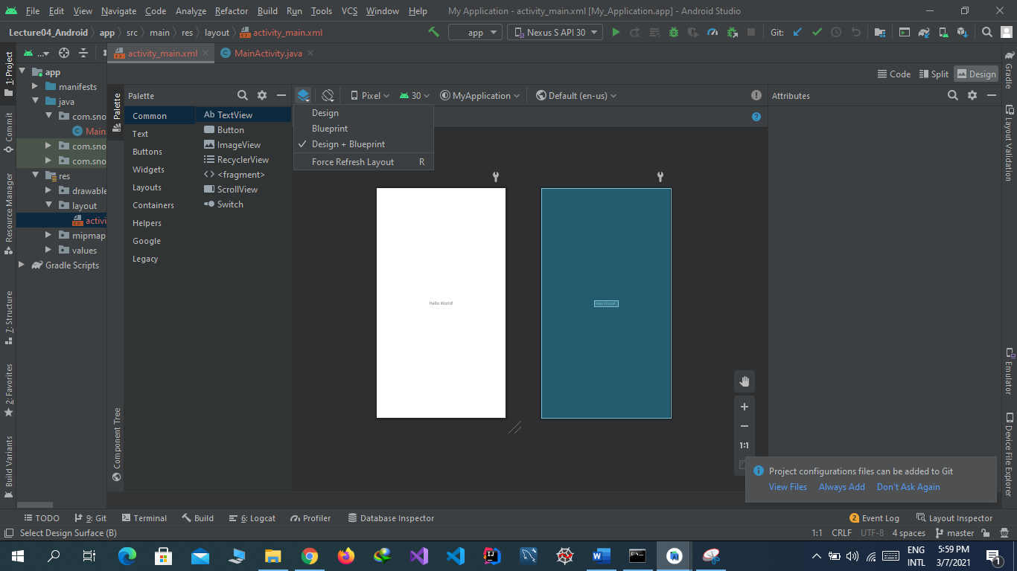

Now the text view attach with four springs. We can adjust position by removing any of these. I remove below spring and see that the text go above.

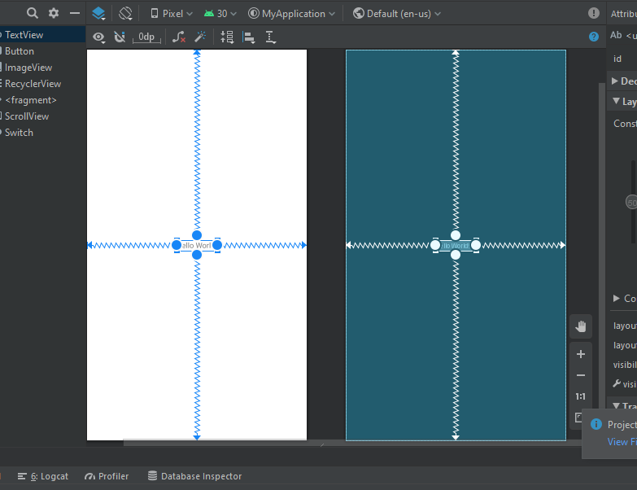

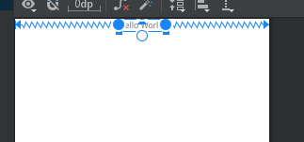

Now change the text by using window tab as select the text view and change the text as:

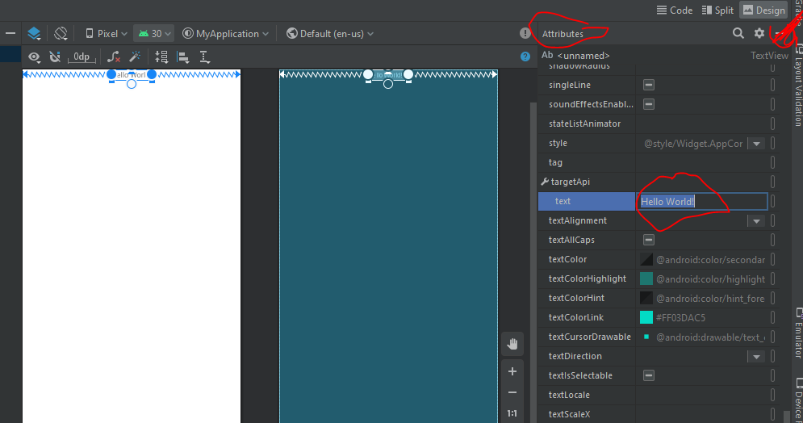

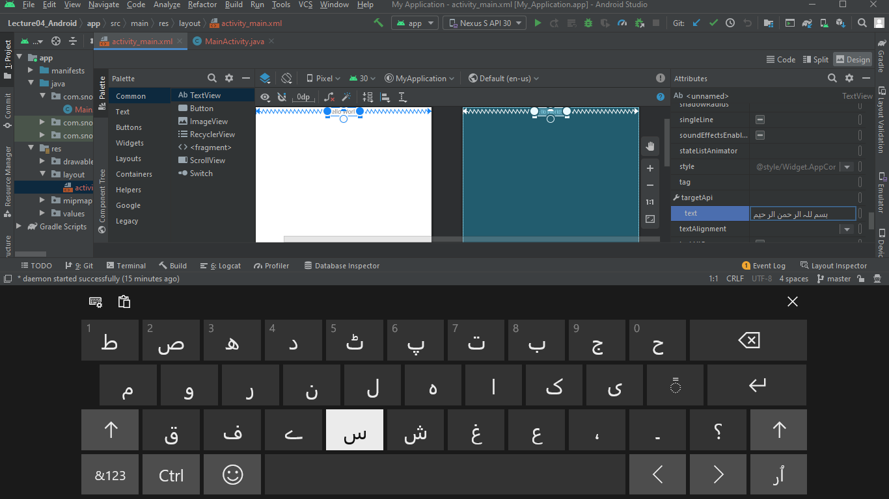

Run code from this:

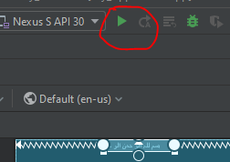

Now see the result:

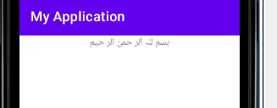

Now increase its size :

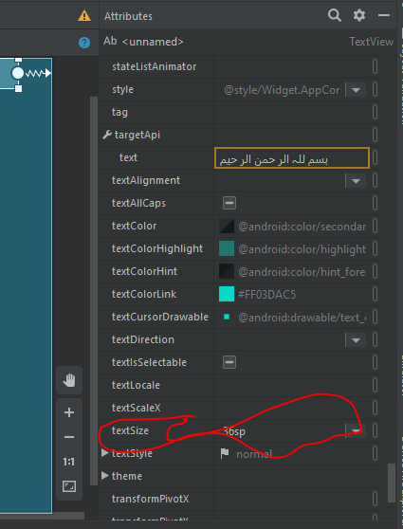

See the result:

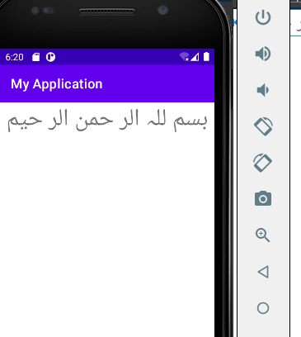

To give padding from the top see this:

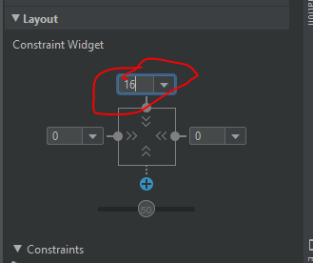

Now see the result:

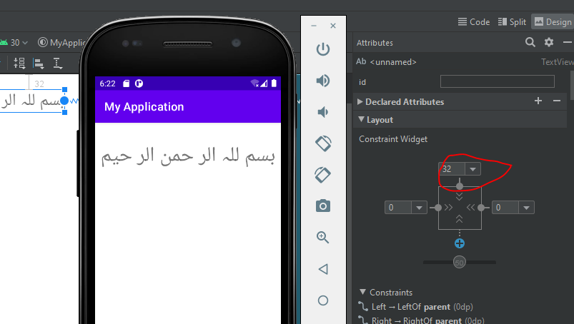

**Home Work:**

**Create three pages**

**First Page:**

Decrease padding to move text to above on the page. Give padding 16 and decrease the size to 14sp.

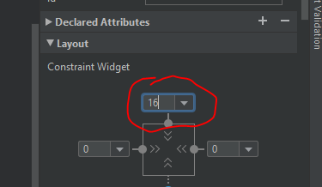

and text size is 14sp:

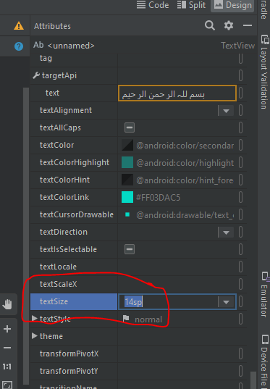

Align text to the center:

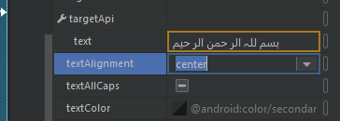

Give italic style:

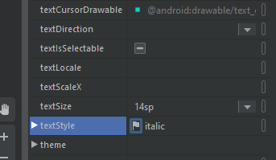

Give color to text now:

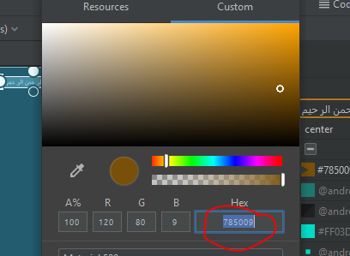

It is in option text color in attributes as:

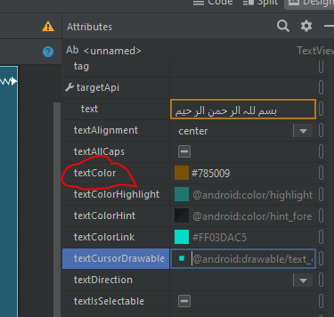

Now see the result:

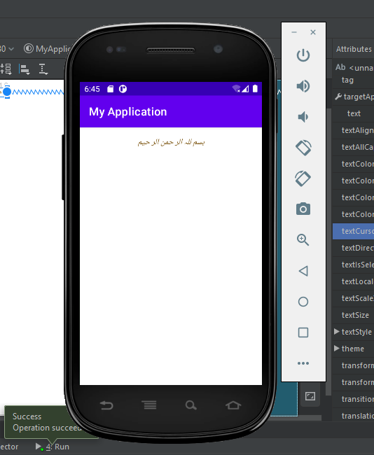

Now add text view by drag and drop from text view option in common option in palette option as:

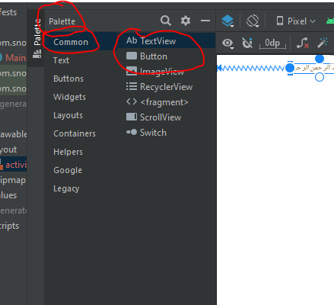

Drag and drop the text view result is :

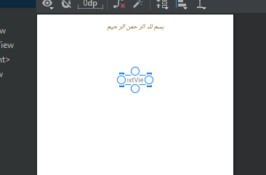

Now add springs from above left and right as:

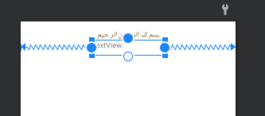

Now add text to it as:

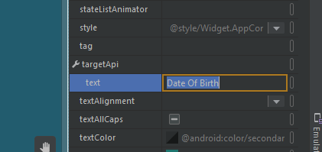

See results:

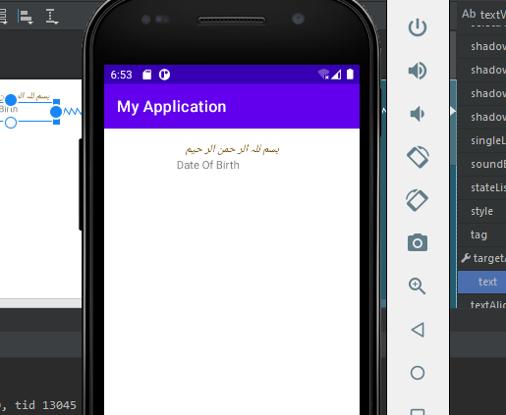

Increase its size:

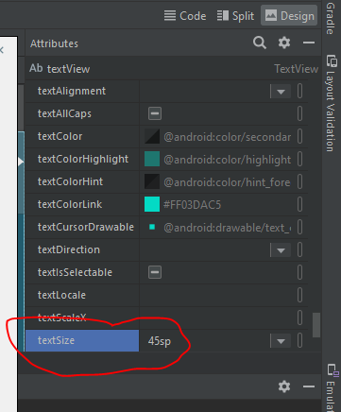

Change the text color:

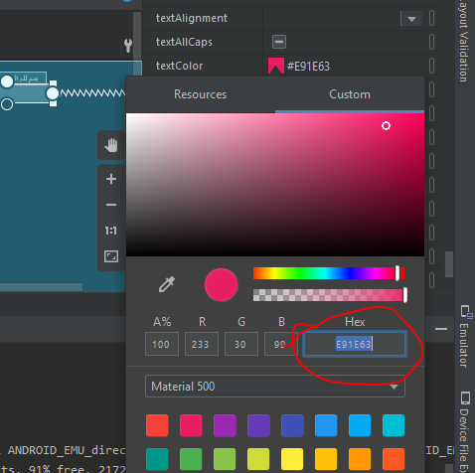

Align this text to center:

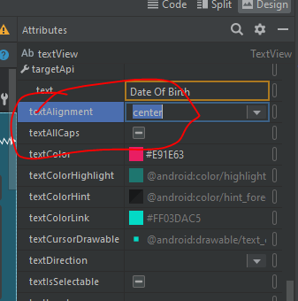

Now give text tyle bold:

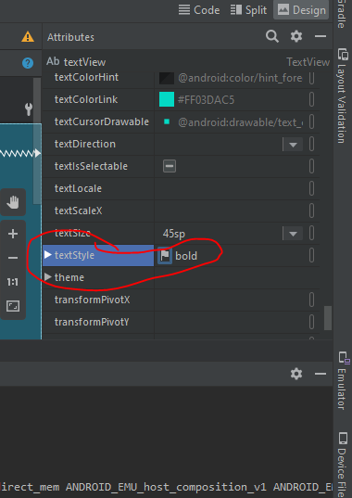

Give top padding 8:

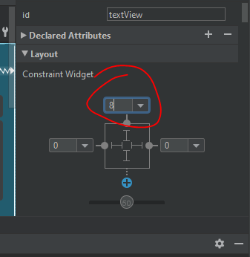

Now see the results:

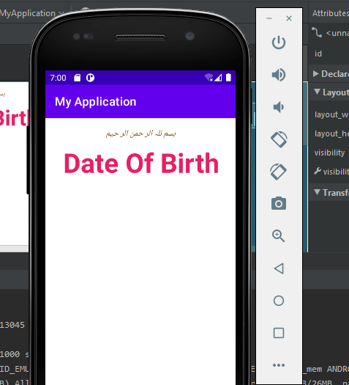

**Second Page:**

Now again add text view by drag and drop from palette->Common->TextView as:

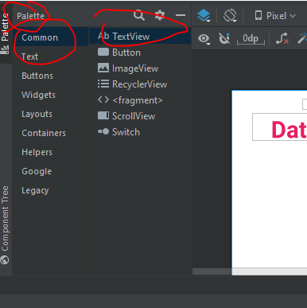

After drag and drop result is:

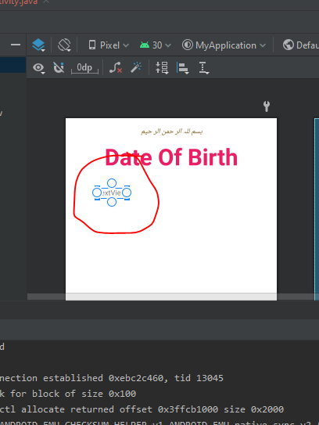

Now add springs from above and left side:

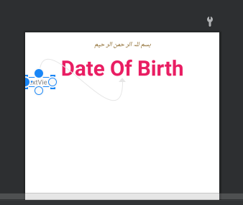

Now add text to it as:

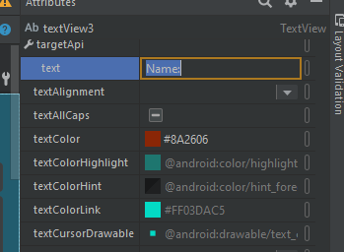

Change the color of text:

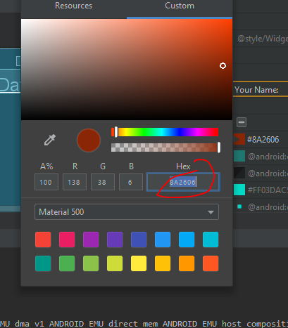

Give text size 18sp:

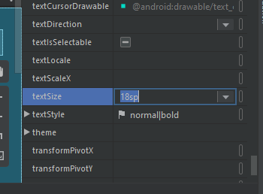

Now give padding from top 16 and from left 8 as:

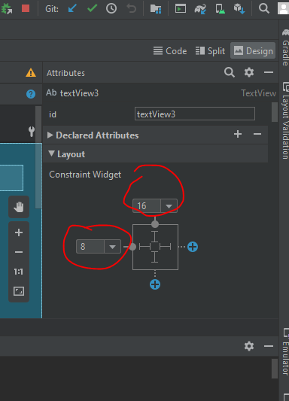

Now see the results:

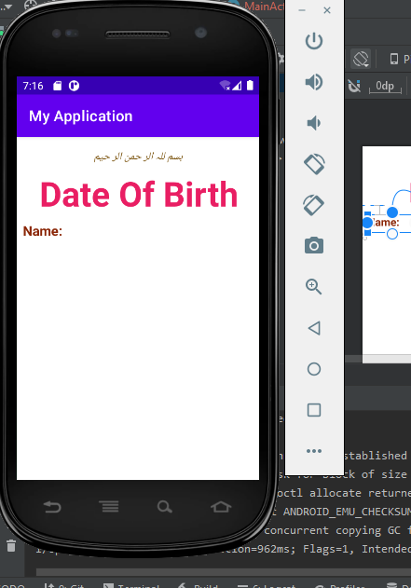

Now add plain text by drag and drop from palette->Text->plaintext as:

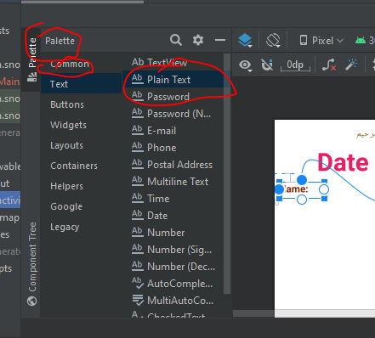

After drag and drop result is:

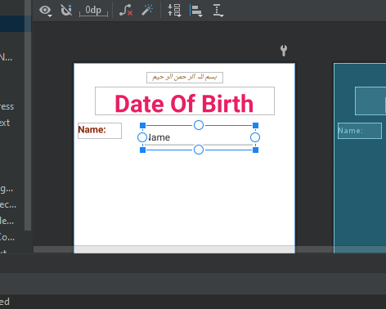

Now add springs:

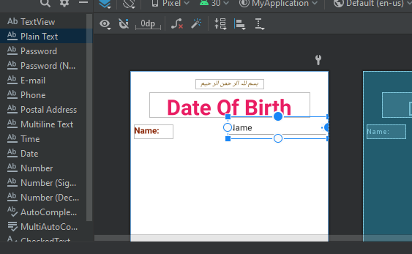

Text keep empty:

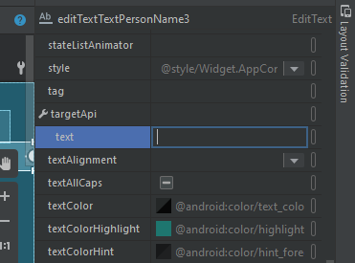

Give size 18sp:

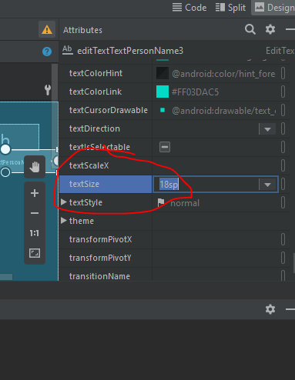

Give color to the text:

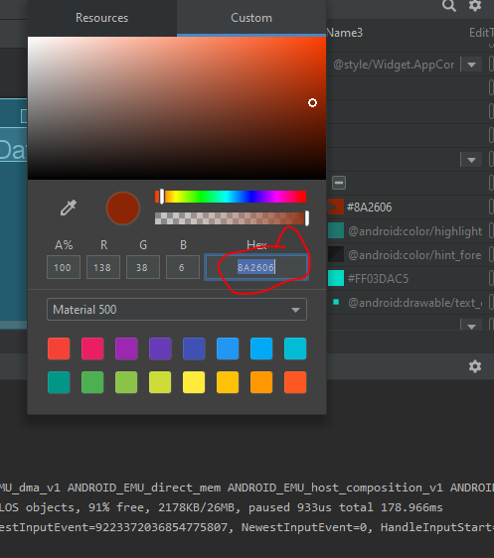

Add padding from right side 16:

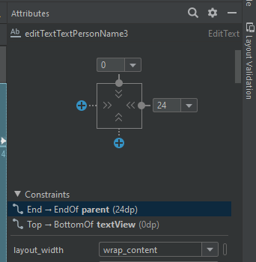

Now see the results:

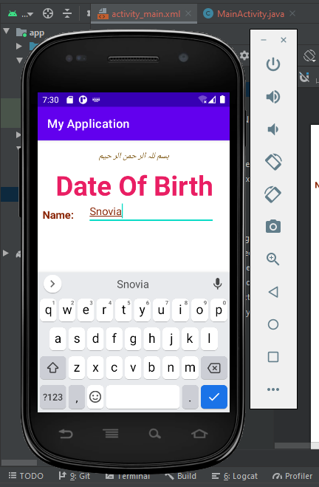

**Third Page:**

Add calendar by drag and drop from palette->Widgets->CalendrarView as:

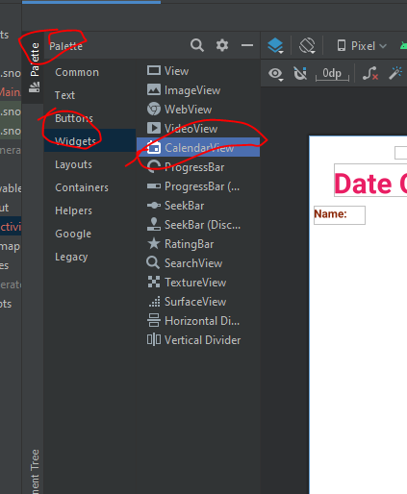

After drag and drop result is:

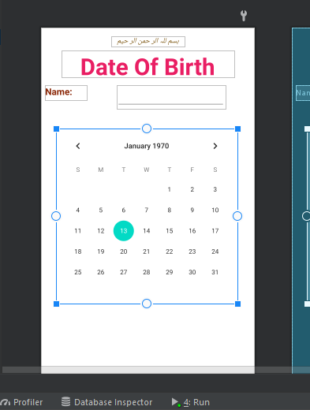

Add springs:

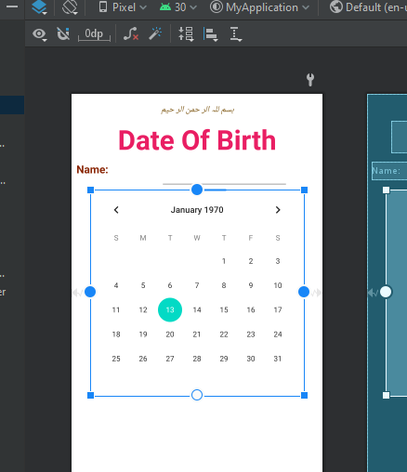

Add padding from the top 8:

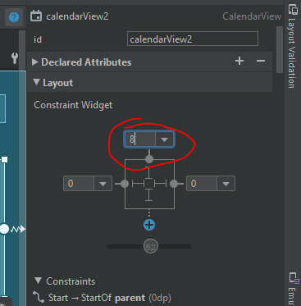

See the results:

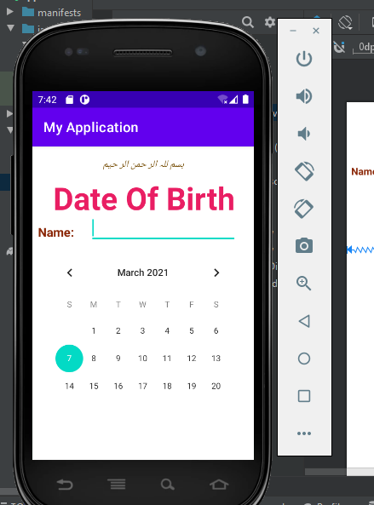

Now add button to submit the data.

For this add button by drag and drop from palette->buttons->button as:

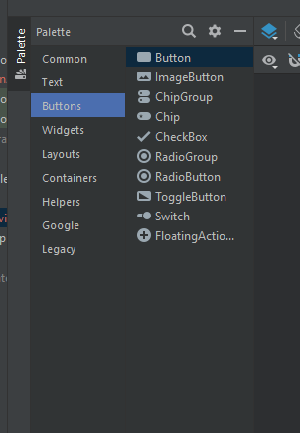

After drag and drop result is:

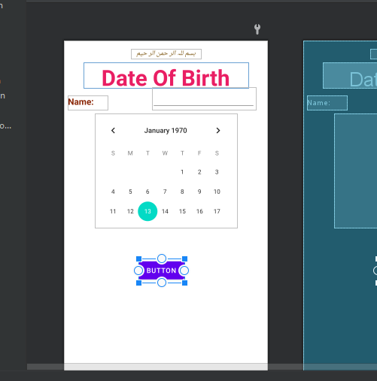

Add springs to left , right and above:

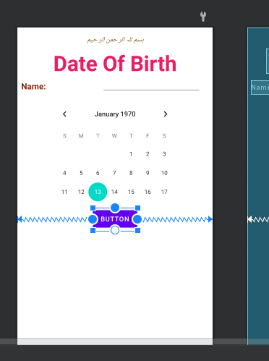

Add text to it:

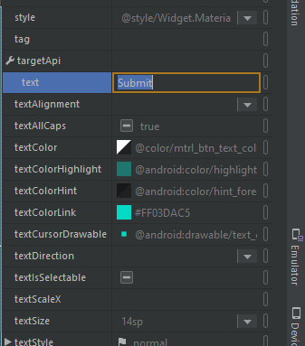

Give color to text:

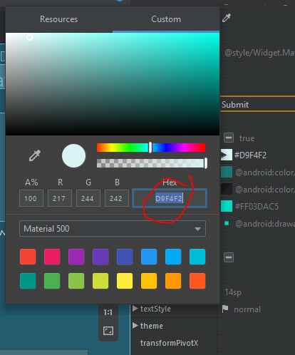

Add padding 8 from top as:

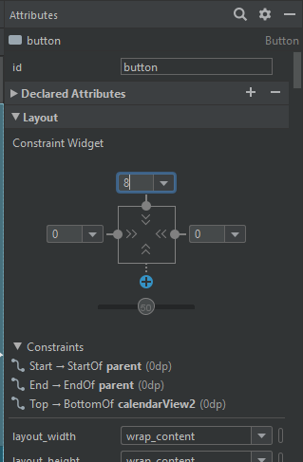

See the results:

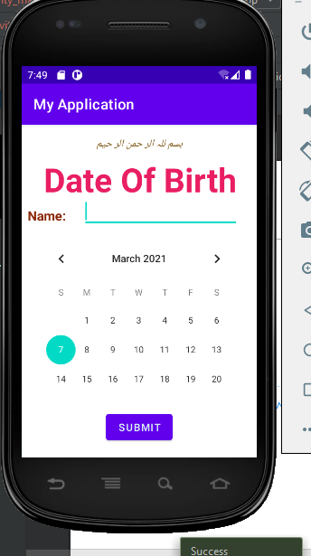

LECTURE 05

Create a new repository in github as:

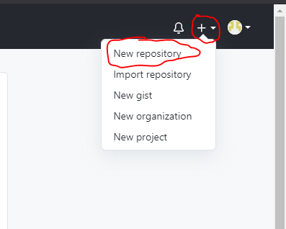

Name this repository lecture05_Android as:

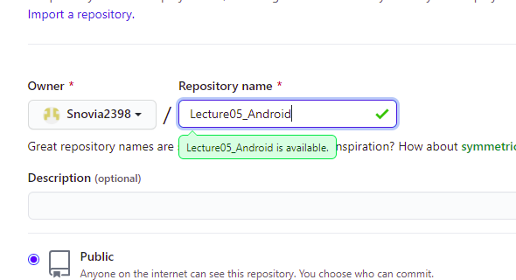

Click on create repository:

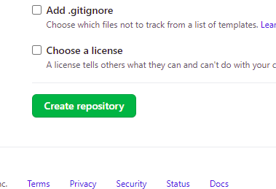

And repository is created:

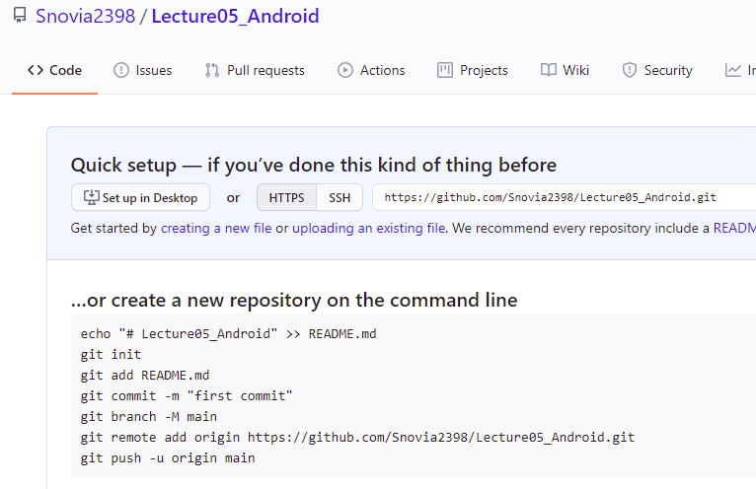

Go to git folder in desktop:

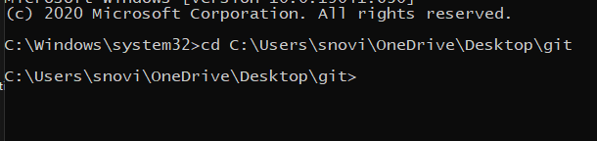

Create clone of repository in this folder by giving the path of repository in command prompt using command git clone address:

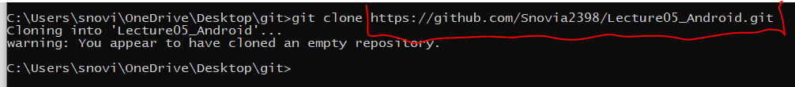

See clone is here:

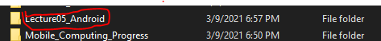

Now create folder in this clone folder named Lecture05:

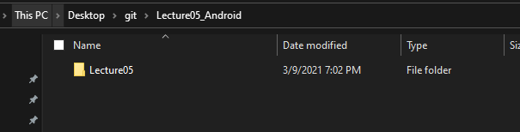

Go to clone folder:

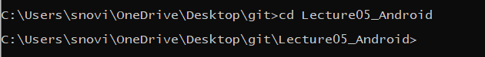

Create a android new project as:

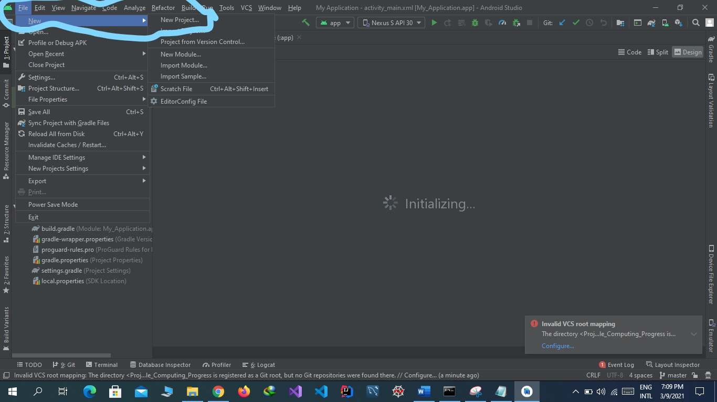

Select empty template and click on next:

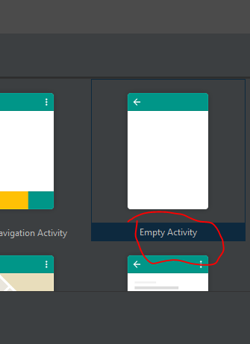

Set name, package name, location language and minimum sdk and click on next button :



Project is created then create a new layout file as:

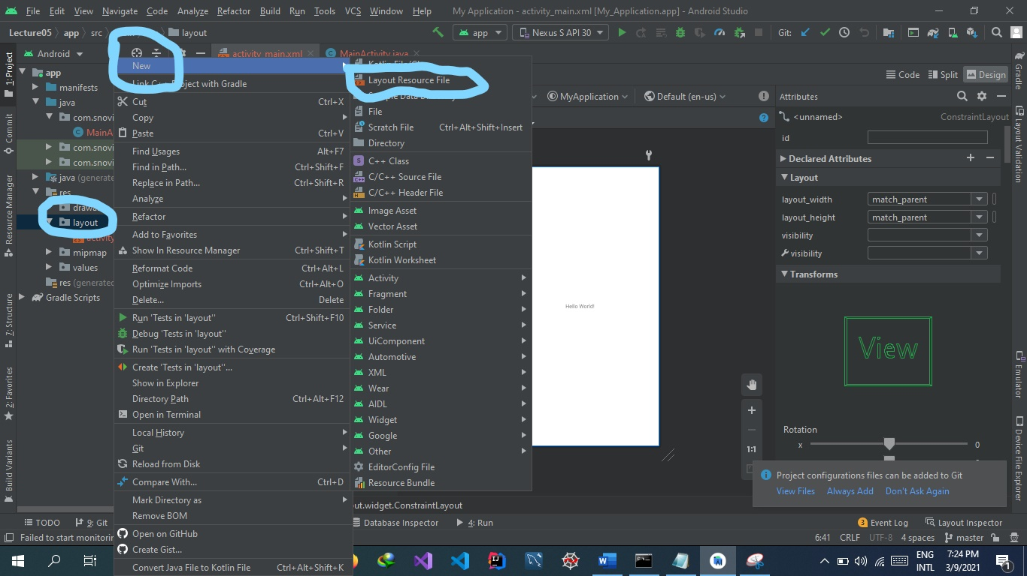

Name this file and select layout and click on finish/ok button:

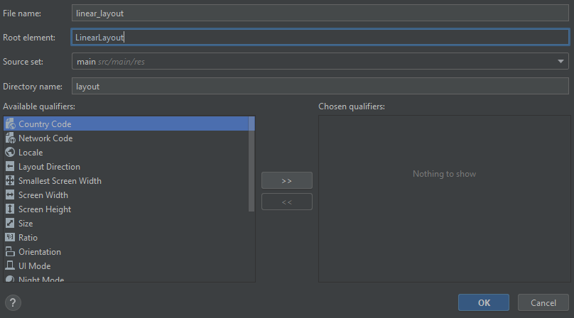

See file layout file is here:

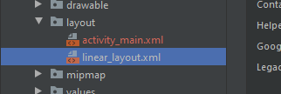

Now insert a textView by drag and drop in its design:

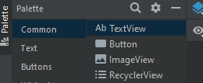

After drag and drop:

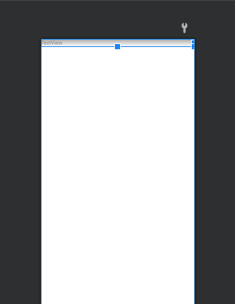

Now add a button by drag and drop: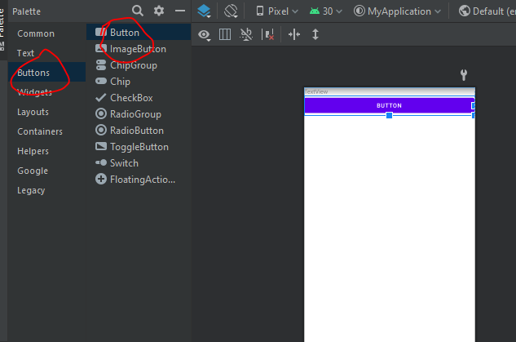

Change the text of text view and button as:

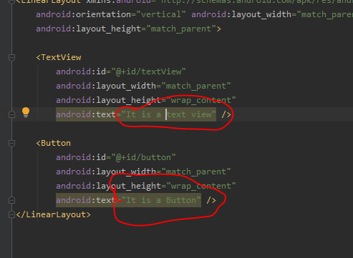

See the text change in design view automatically:

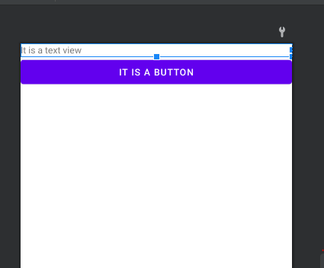

Now set the content type to linear_layout instead of activity_main.xml to run the linear_layout code as:

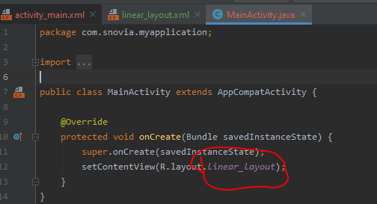

Run the code and see this file output is displayed now:

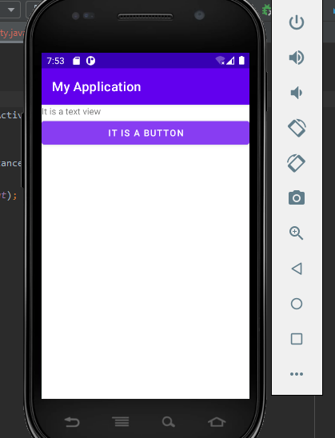

Push the android project folder Lecture05 to github using commands:

git add Lecture05

git commit -m "Linear layout apply"

git push

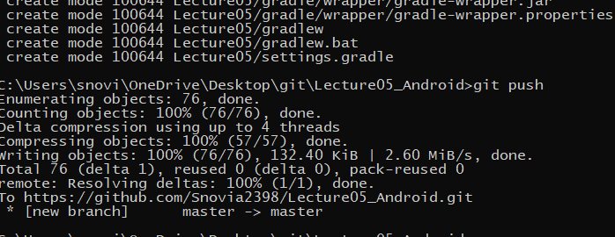

See the folder is in the repository

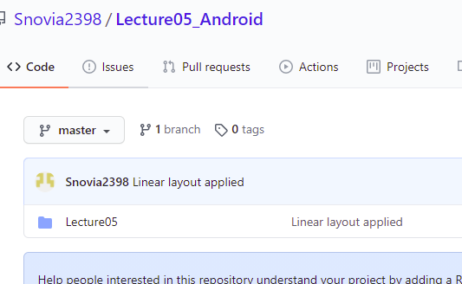

Create a button and add springs to it as:

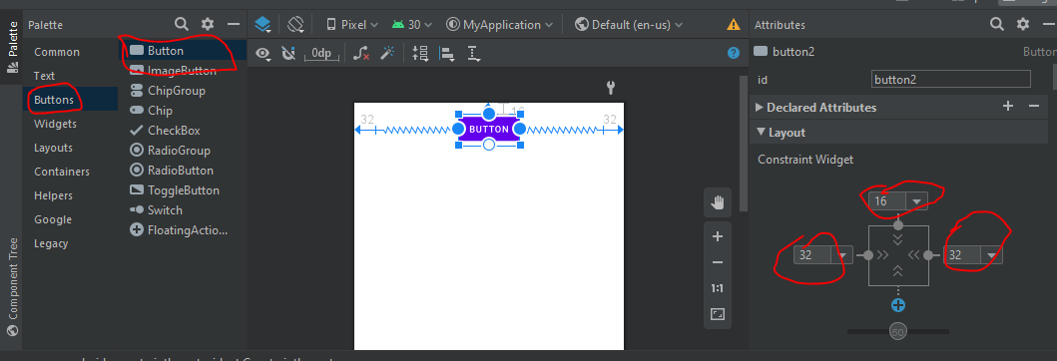

See the results:

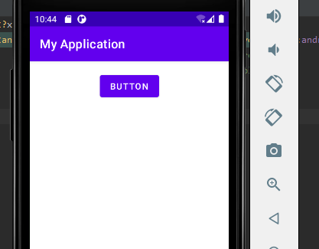

If we right click the button we can delete all constraints as:

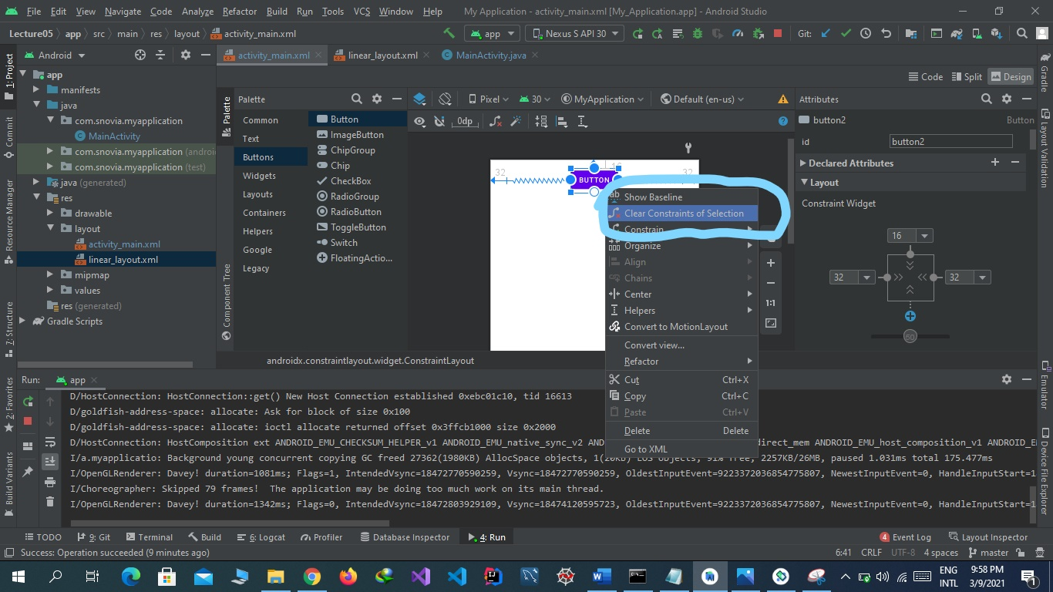

Push this to github as:

git add Lecture05

git commit -m "without constraints"

git push

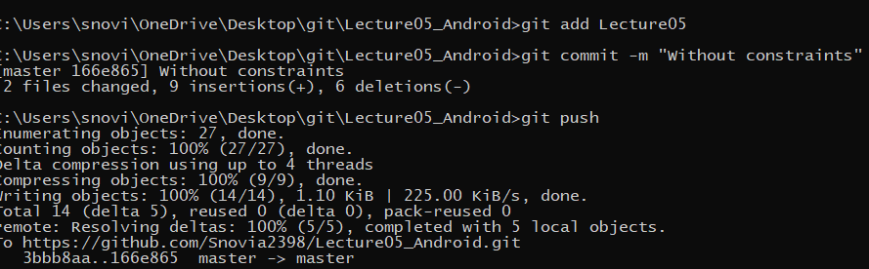

See all constraints are deleted:

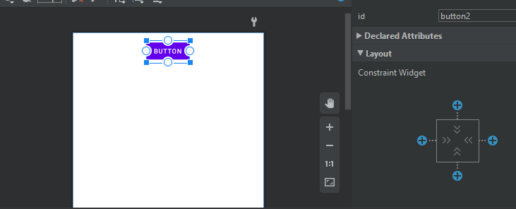

See the result:

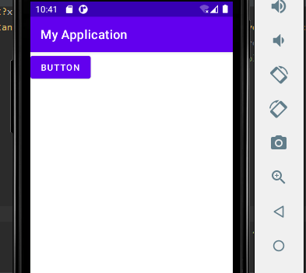

Again add this to github:

git add Lecture05

git commit -m "Delete constraints"

git push

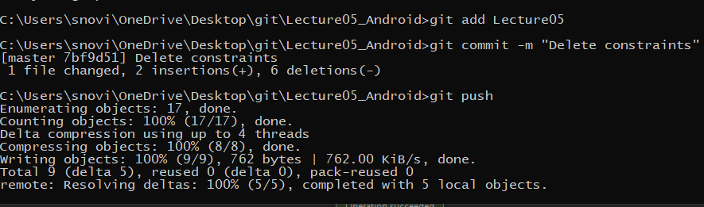

See commit on github:

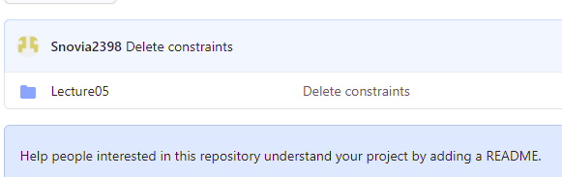

Add 8 buttons by drag and drop as:

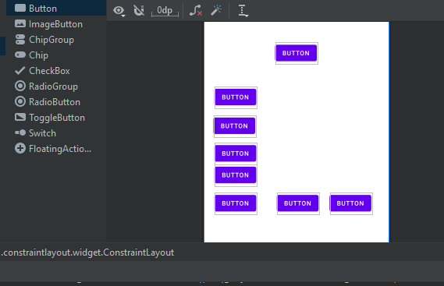

Now add springs:

Above button as:

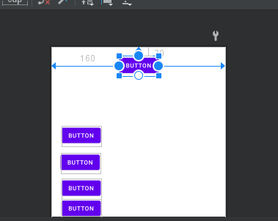

Button 1 as:

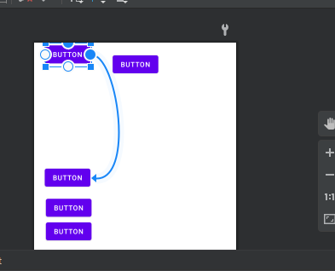

Button 2 as:

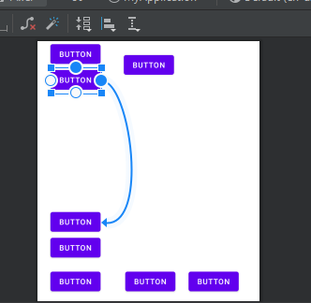

Button 3 as:

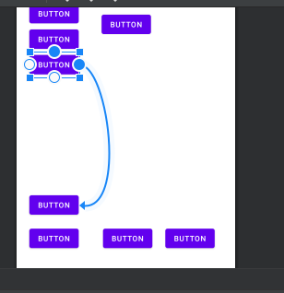

Button 4 as:

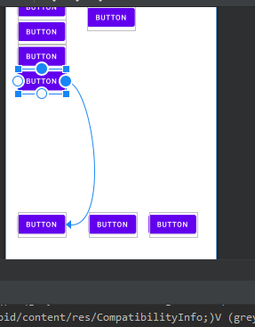

Button5 as:

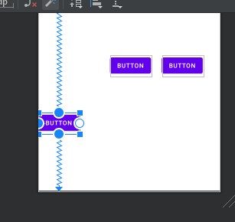

Button 6 as:

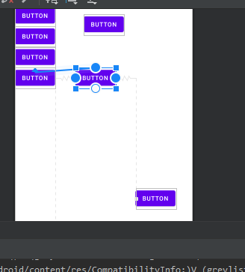

Button 7 as:

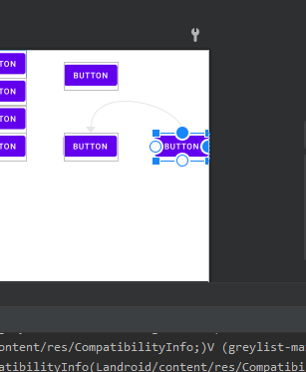

Output is as:

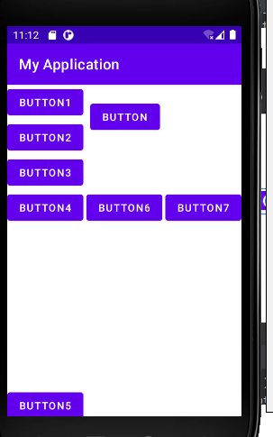

Push this to github:

git add Lecture05

git commit -m "Buttons layout before changing"

git push

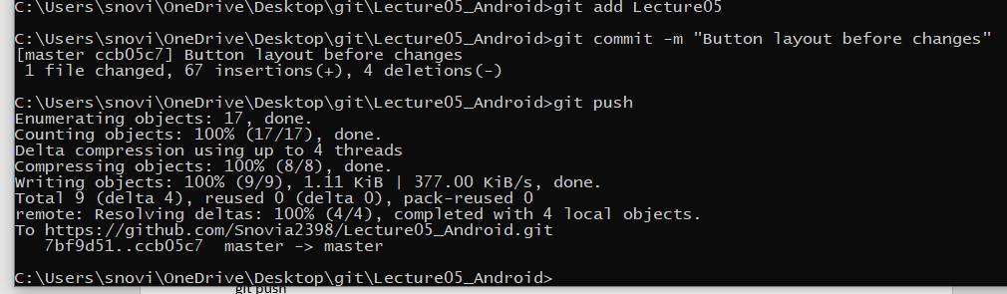

Added:

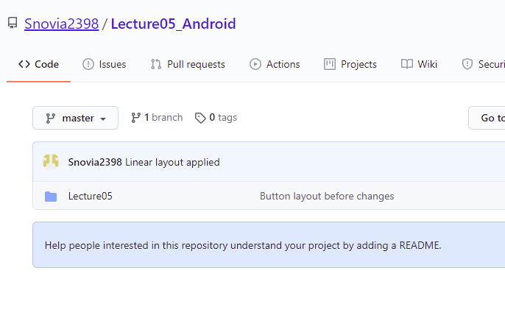

Change upper constraint off button1 as:

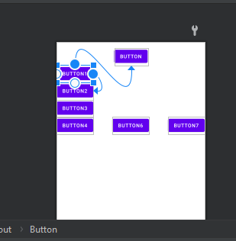

See the results:

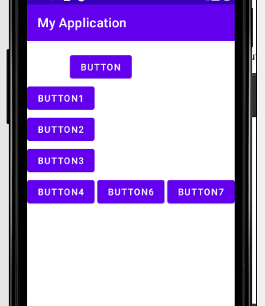

Again change the constraints:

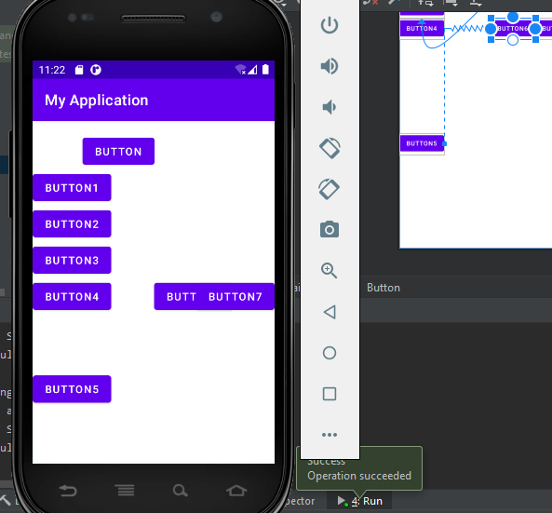

Again change the constraints and result is:

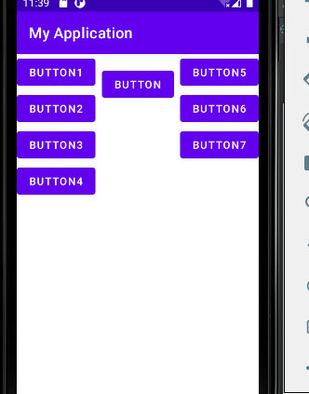

Push this to github:

git add Lecture05

git commit -m "Buttons layout after changing constraints"

git push

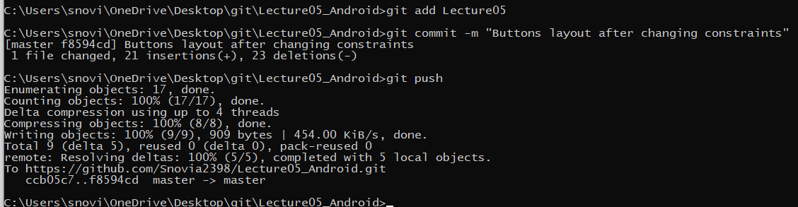

Added:

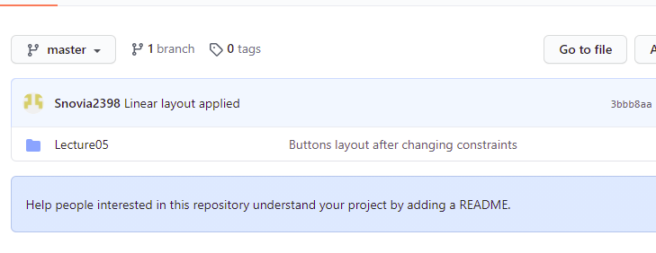

Now copy an image and paste it into drawable:

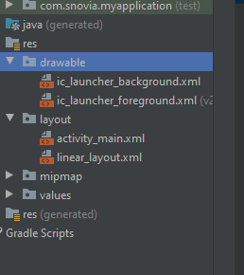

Click on ok button:

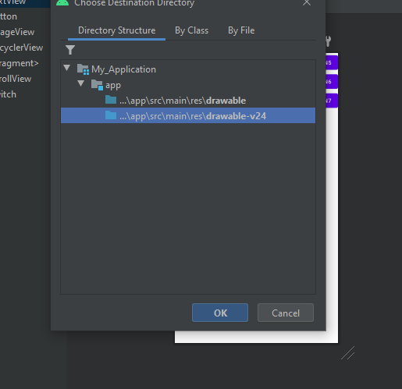

See images are added:

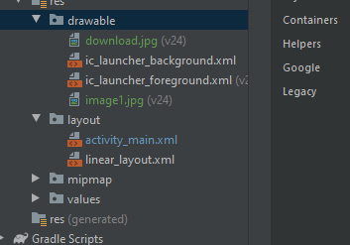

Now add a text view by drag and drop and an image by image view :

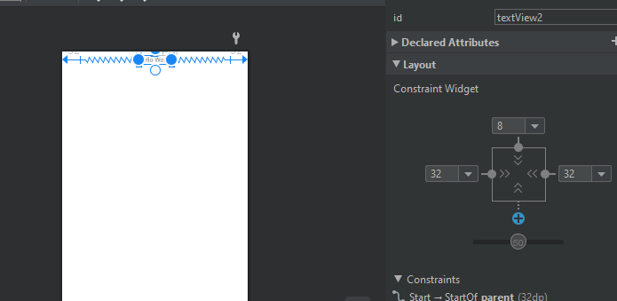

Image by drag image view as:

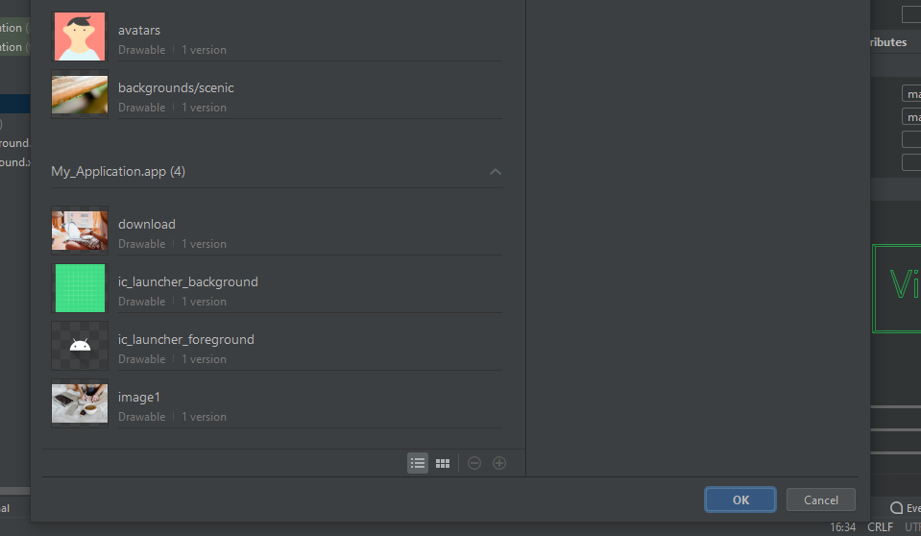

Click on add button and image is added:

C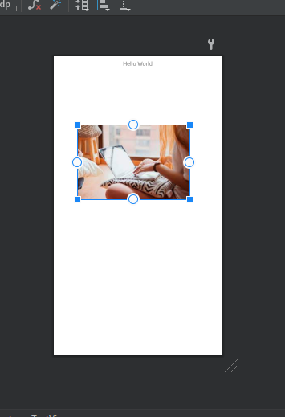

Change the height:

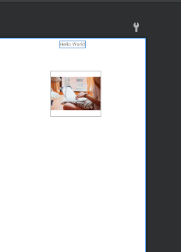

Run the code and see the result:

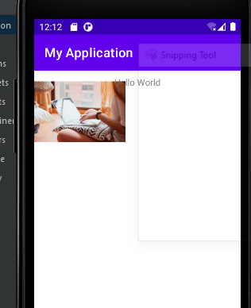

This is because constraints are not added. Now add constraints and see the result:

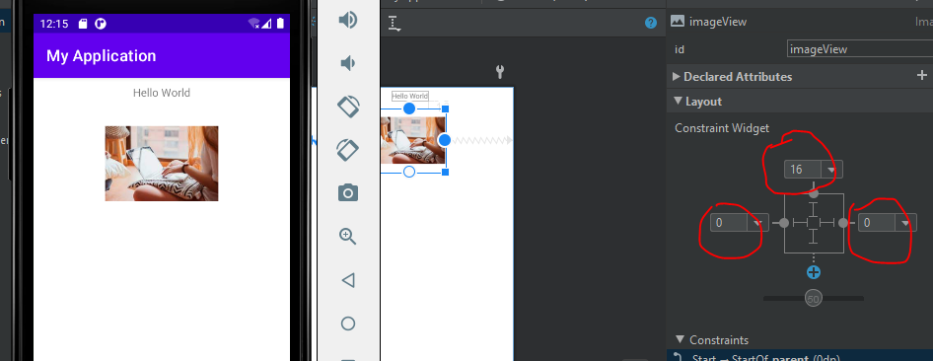

Push to github:

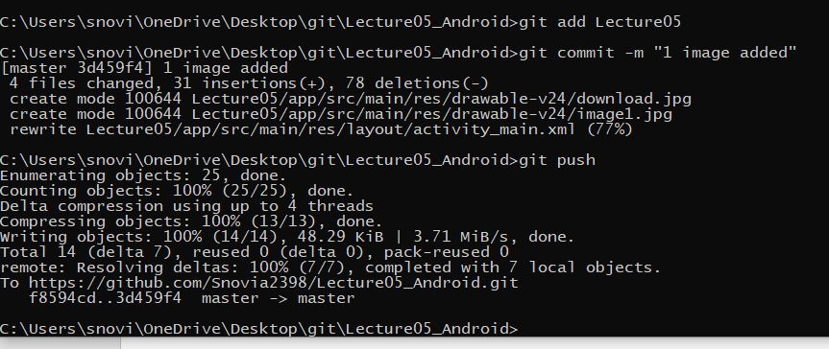

See added:

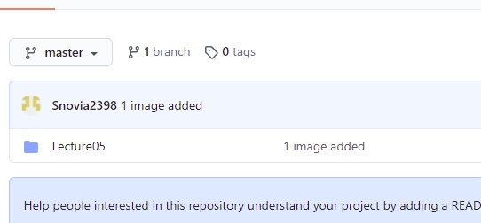

Now add another image:

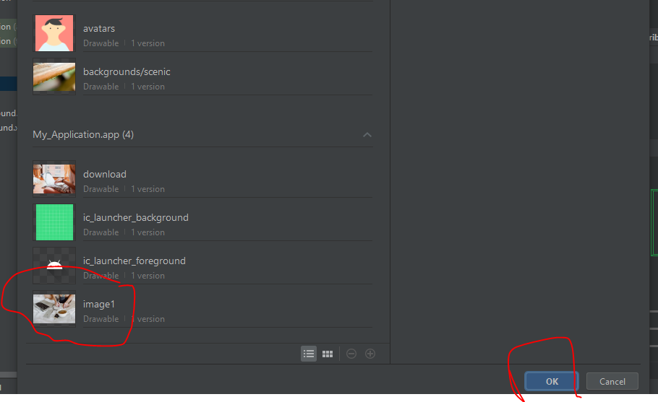

Add constraints and adjust height:

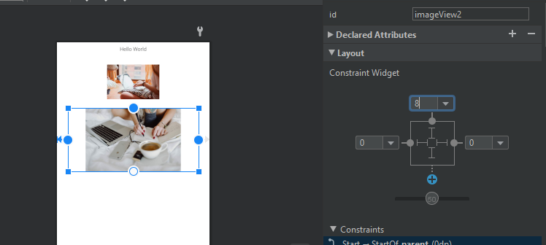

See the result:

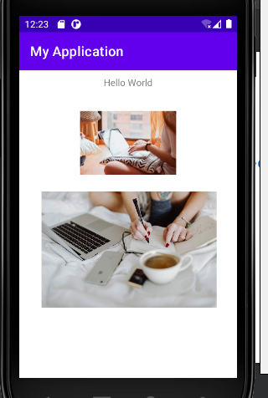

Push to github:

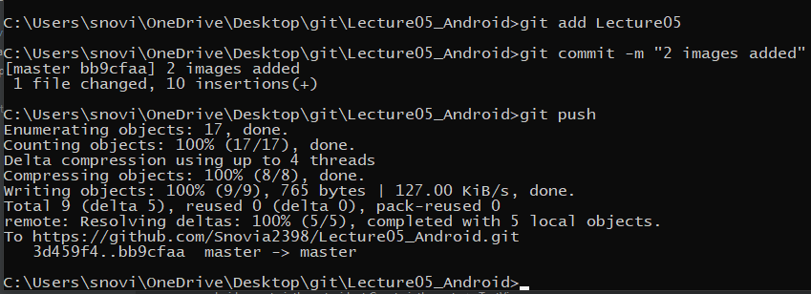

Added:

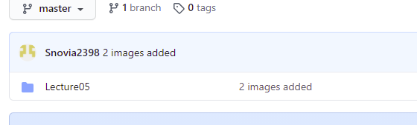

Now adjust buttons:

Drag and drop three buttons:

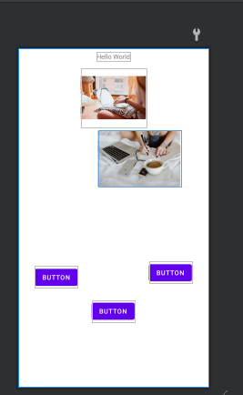

Select three buttons simultaneously and align them :

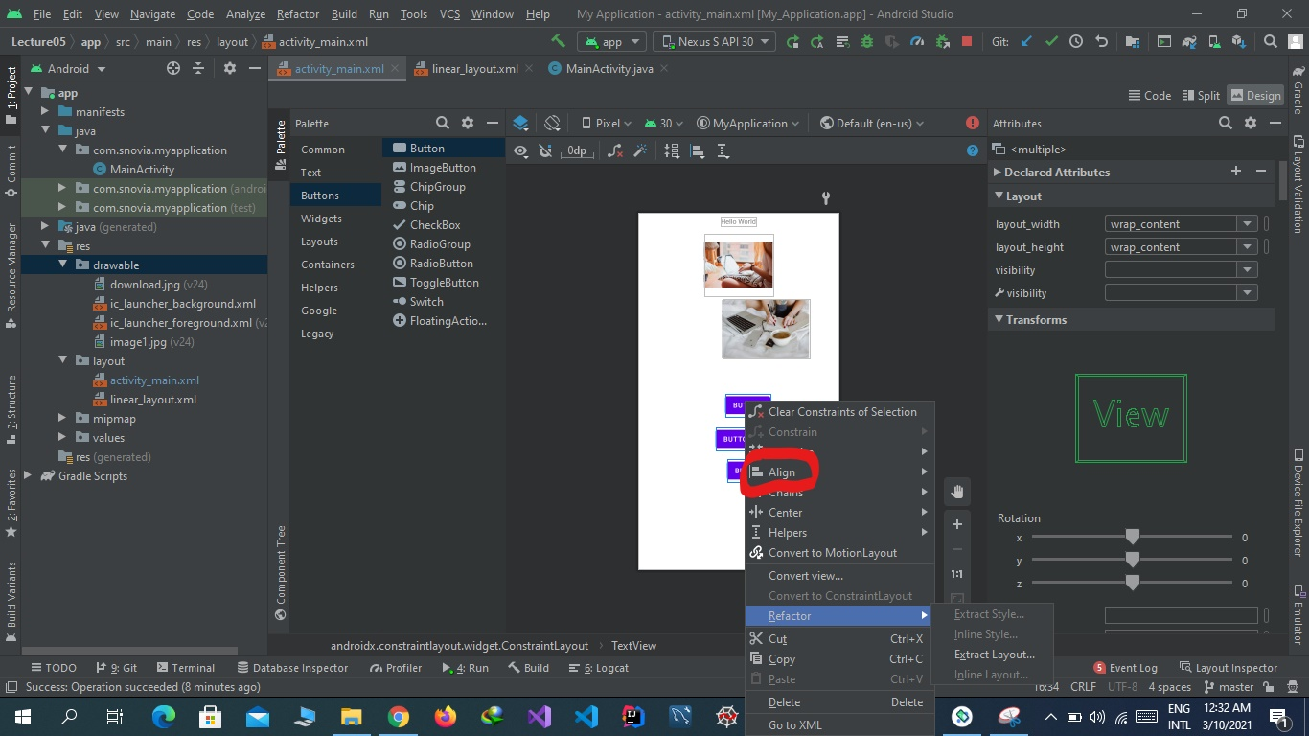

See the results:

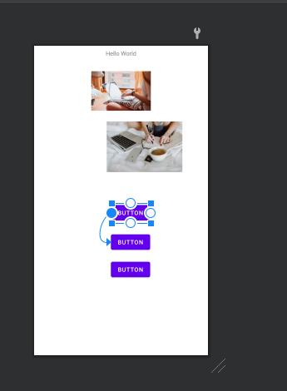

Center the buttons horizontally:

Select buttons and center them horizontal:

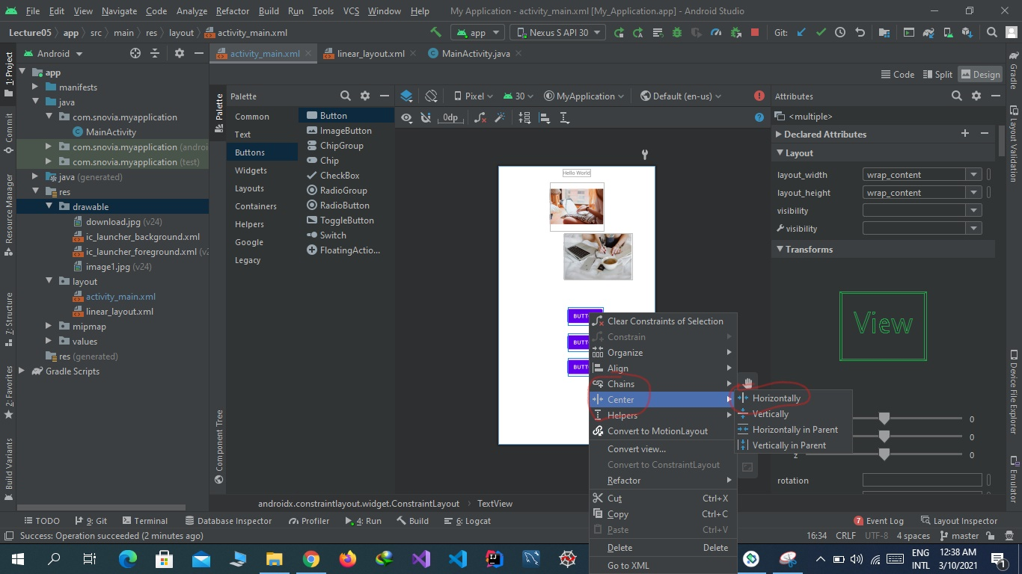

See the results:

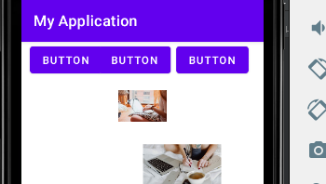

To expand the buttons horizontally select buttons and select expand horizontaaly:

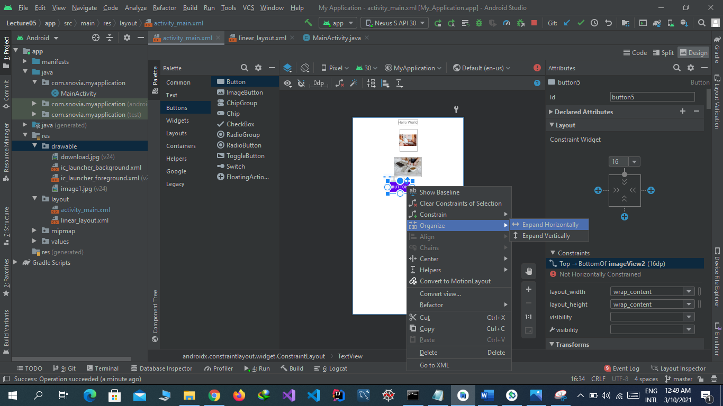

See the result:

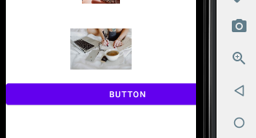

Push this to github:

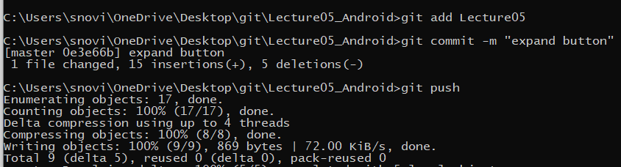

Added:

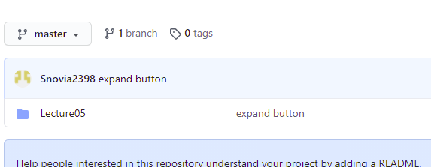

Same in case of vertically expand.